**Exercise 1: Implementing the Singleton Pattern**

A logging utility class in your application has only one instance throughout the application lifecycle to ensure consistent logging.

***CODE:***

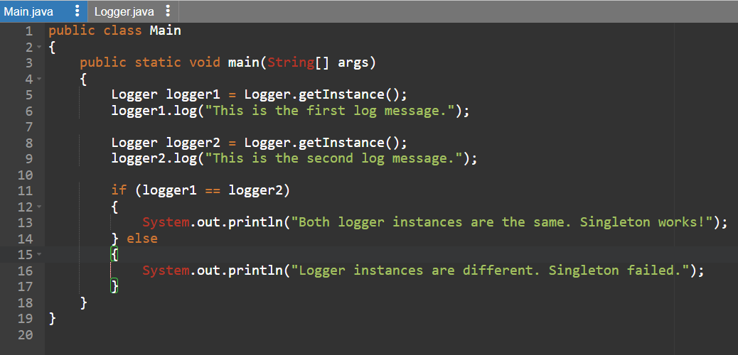

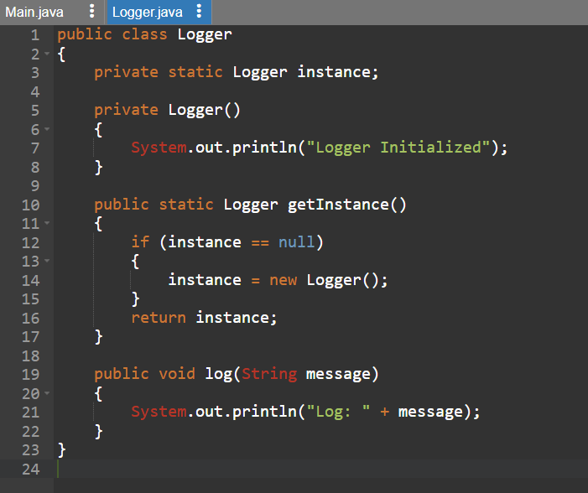

***OUTPUT:***

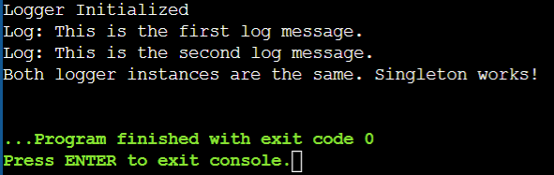

**Exercise 2: Implementing the Factory Method Pattern**

A document management system that creates different types of documents (e.g., Word, PDF, Excel) using the Factory Method Pattern.

***CODE:***

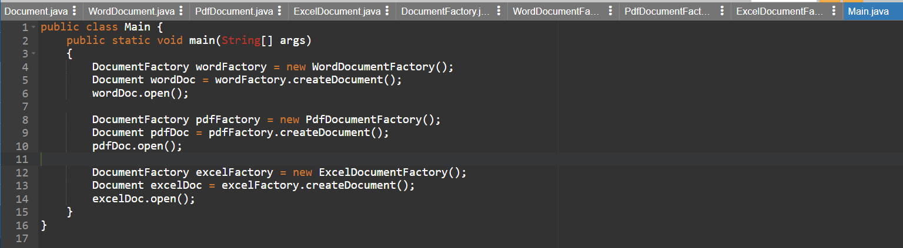

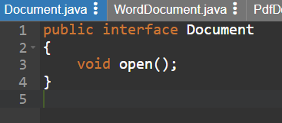

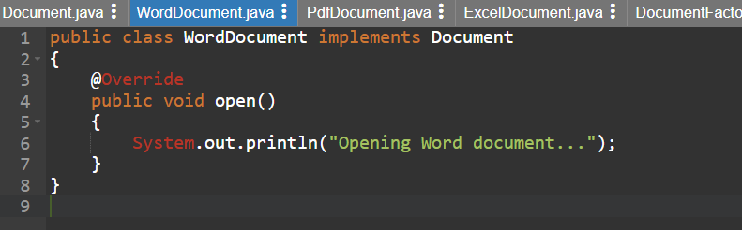

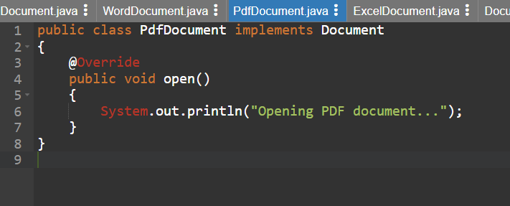

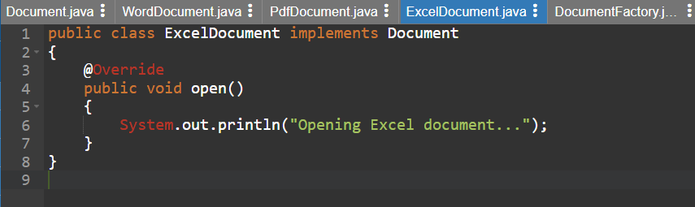

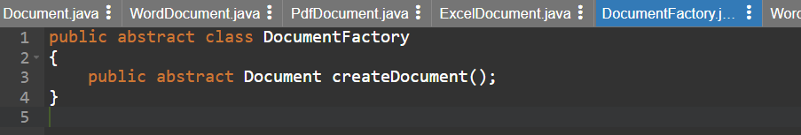

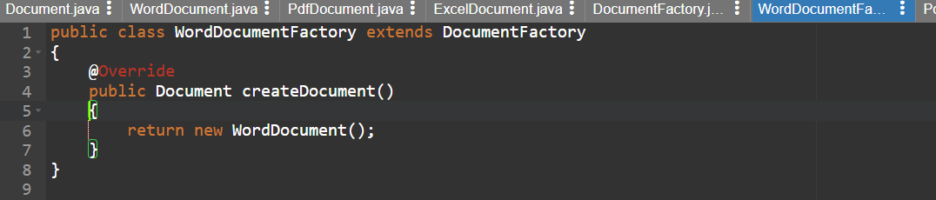

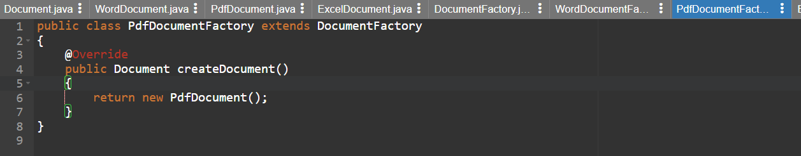

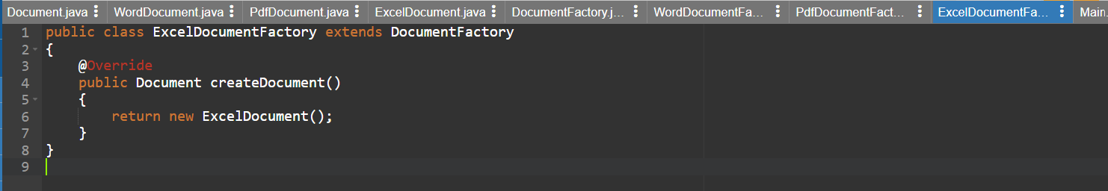

***OUTPUT:***

